|  |  |  |  |
| --- | --- | --- | --- |
| **Name of Student: Pushkar Sane** | | | |
| **Roll Number: 45** | | **Lab Assignment Number: 2** | |
| **Title of Lab Assignment: Create an application to demonstrate Node.js modules.** | | | |
| **DOP: 12-09-2023** | | **DOS: 13-09-2023** | |
| **CO Mapped:**  **CO1** | **PO Mapped:**  **PO3, PO5, PSO1, PSO2** | **Faculty Signature:** | **Marks:** |

**Practical No. 2**

**Aim:**

Create an application to demonstrate the Node.js modules.

**1) Built-in modules**

1. Write a program to print information about the computer’s operating system using the OS module (Use any 5 methods).
2. Print “Hello” every 500 milliseconds using the timer module. The message should be printed exactly 10 times. Use SetInterval, ClearInterval and SetTimeout methods.

**2) Custom Modules**

1. Create a Calculator Node.js Module with functions add, subtract and multiply, Divide. And use the Calculator module in another Node.js file.
2. Create a circle module with functions to find the area and perimeter of a circle and use it.

**Theory:**

1. **Built-in Module:**

In Node.js, built-in modules are pre-existing libraries and modules that are included with the Node.js runtime environment. These modules provide a wide range of functionalities to help developers perform common tasks and interact with various aspects of the system. Below are some of the examples of built in modules.

1. **fs (File System):** Used for reading and writing files, as well as manipulating directories.
2. **http and https:** Modules for creating HTTP and HTTPS servers and making HTTP requests.
3. **os (Operating System):** Provides information about the operating system.
4. **path:** Helps in working with file and directory paths.
5. **events:** Allows you to create and handle custom events.
6. **crypto:** Offers cryptographic functionality for hashing, encryption, and decryption.
7. **util:** Provides utility functions for debugging and formatting.
8. **Custom Module:**

Custom modules in Node.js are user-defined JavaScript files that encapsulate specific

functionality, making code more organized, modular, and reusable.

1. Organize code into smaller, manageable units.
2. Promote code reusability across your application.
3. Improve code readability and maintainability.
4. Extend Node.js capabilities beyond built-in modules.

Custom modules are essential for building scalable and maintainable Node.js applications by facilitating code modularization and promoting best practices in software development.

1. **Write a program to print information about the computer's operating system using the OS module (use any 5 methods).**

**Code:**

const os = require('os');

console.log('Operating System Platform:', os.platform());

console.log('Operating System Type:', os.type());

console.log('Operating System Release Version:', os.release());

console.log('CPU Architecture:', os.arch());

console.log('Total System Memory (RAM):', os.totalmem(), 'bytes');

**Output:**

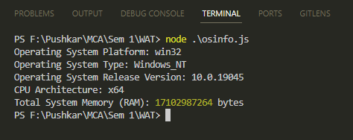

1. **Print "Hello" every 500 milliseconds using the Timer Module. The message should be printed exactly 10 times. Use SetInterval, ClearInterval and SetTimeout methods.**

**Code:**

let count = 0;

const intervalId = setInterval(() => {

console.log("Hello");

count++;

if(count == 10){

clearInterval(intervalId);

}

}, 500);

setTimeout(() => {

clearInterval(intervalId);

},5500);

**Output:**

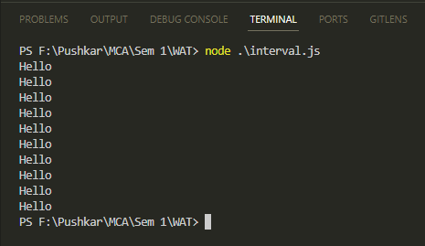

1. **Create a Calculator Node.js Module with functions add, subtract and multiply, Divide. And use the Calculator module in another Node.js file.**

**Code:**

**Calculator.js**

function add(a, b){

return(a + b);

}

function subtract(a, b){

return(a - b);

}

function multiply(a, b){

return(a * b);

}

function divide(a, b){

if(b === 0){

throw new Error("Divide by zero error!")

}

return(a / b);

}

module.exports = {

add,

subtract,

multiply,

divide,

};

**Calculator_App.js**

const calculator = require('./calculator');

const num1 = 10;

const num2 = 5;

console.log(`Addition: ${num1} + ${num2} = ${calculator.add(num1, num2)}`);

console.log(`Subtraction: ${num1} - ${num2} = ${calculator.subtract(num1, num2)}`);

console.log(`Multiplication: ${num1} * ${num2} = ${calculator.multiply(num1, num2)}`);

console.log(`Division: ${num1} / ${num2} = ${calculator.divide(num1, num2)}`);

**Output:**

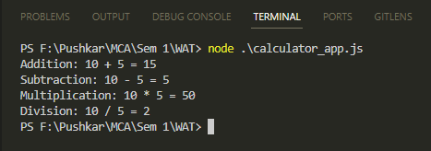

1. **Create a circle module with functions to find the area and perimeter of a circle and use it.**

**Code:**

**Circle.js**

function CalculateArea(radius){

return Math.PI * Math.pow(radius, 2);

}

function calculatePerimeter(radius){

return 2 * Math.PI * radius;

}

module.exports = {

CalculateArea,

calculatePerimeter,

};

**Circle_App.js**

const circle = require('./circle');

const radius = 7;

const area = circle.CalculateArea(radius);

const perimeter = circle.calculatePerimeter(radius);

console.log(`Radius: ${radius}`);

console.log(`Area: ${area.toFixed(2)}`);

console.log(`Radius: ${radius.toFixed(2)}`);

**Output:**

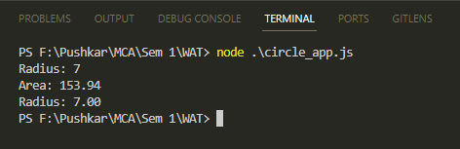

**Conclusion:**

Created an application by using Node.js modules such as,

* Built-in Module
* Custom Module